Little SPARK: Simple Play Adaptations to Reference for Kids

First-Then Flip Schedule
Description: | Image:
First-Then Flip Schedule consists of black velcro sensitive (loop) fabric pages for attaching word/picture prompts for task order; designed for you to add your own words signifying the order of step One and Two, or activity and reinforcer, to help motivate to the next task.  Purchasing Information | 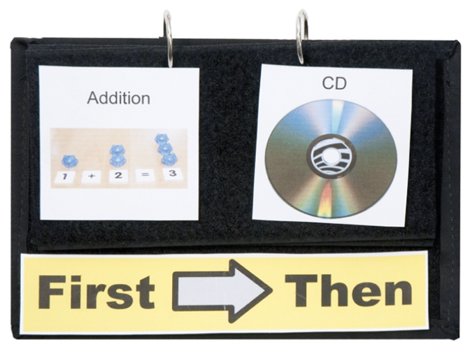

Who Might Benefit?
Those who benefit from structure, need support understanding or following routines, and are motivated by seeing and interacting with a clear, predictable sequence of activities.
Why Use?
A visual "first-then" schedule helps children understand and follow the sequence of activities, supports smoother transitions, introduces new tasks in a motivating way, and builds independence by clarifying expectations.
Instructions for Use: | Adaptation Ideas:
Environmental Considerations  - Use in any environment throughout the day.  Positioning & Alternate Positioning  - Use in any position for easy viewing and manipulating.  Basic Play/Use Extended Play/Use  - Present the schedule to the child Allow the child to choose the “Then” activity when appropriate. | Additional Materials  - Velcro, foam board, Dycem, or carpet square.  Build It Up  - Reinforce the pages with cardboard.  - Add page fluffers.  Stabilize It  - Fasten the schedule to a surface so that it doesn’t shift during viewing or manipulating.  Simplify It  - Use objects to show the sequence.  Contain It  - Place completed activities from First Then in folder, sleeve, or envelope to show the child what they accomplished.  Add Sensory Cues  - Draw Use real objects, symbols outlined in puffy paint, or high contrast visuals.  - Narrate the schedule.  Alternative Uses/DIY  - Paper-based or dry erase boards first-then schedules.

Words to Encourage Play/Use
First  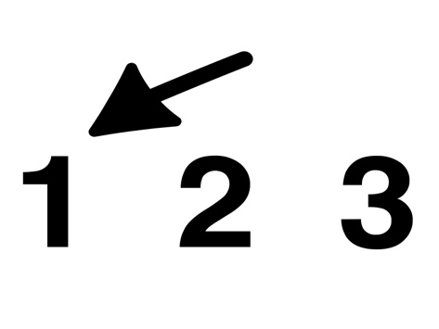 | Then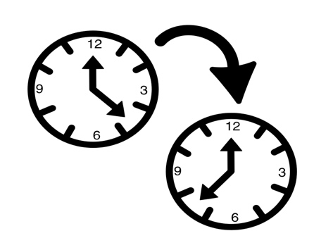 | Next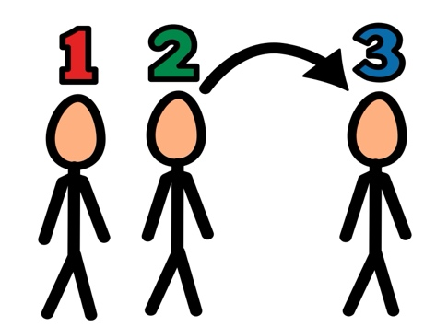
Done | Flip | Ready
Schedule | Today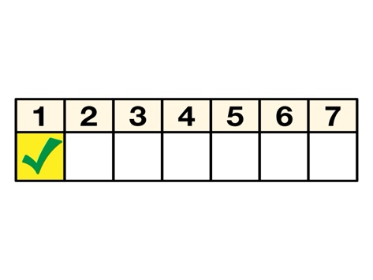 | Help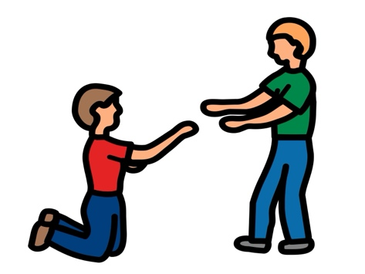
*”Adaptations” adapted from: Haugen’s Modes for Adapting Toys based on materials from the "Let's Play" Project at the University of Buffalo
PCS is a trademark of Tobii Dynavox, LLC. All rights reserved. Used with permission.

